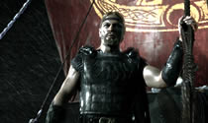
Film Techniques
Glossary

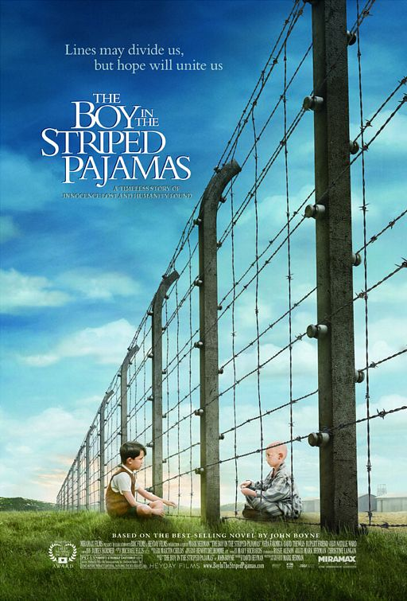

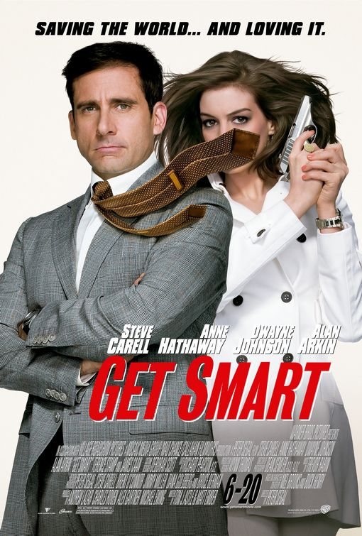

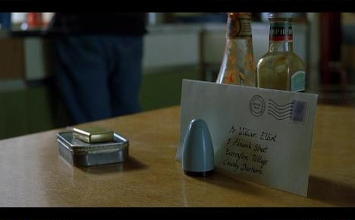

A reference resource created by Jess Bootes, Muirfield High School, 2009
A note on studying novel/text to film:
Despite its debt to other forms and especially the novel, film tells its story with its own grammar, its own syntax. Camera movement, camera position, framing, lighting, sound, and editing are some of the main vocabulary by which a director or screenwriter may express a narrative. A film of a novel therefore is far from being a mechanical copy of the source - it is rather a transposition or translation from one set of conventions for representing the world to another. Why this should be so, what is the nature of this transposition and for whom is it done, what is 'gained' and what 'lost' - these are some of the questions necessarily addressed when the 'film of the book' is explored in a class.

Shot → Scene → Sequence

Shot type Framing – what’s included and excluded in a shot.
Establishing shot - A shot in which figures appear small in the landscape. Often used at the beginning of a film or sequence to show where the action is taking place; also used to make a figure appear small or isolated.
Long shot - A shot in which a figure can be seen from head to toe, shows some background.
Mid shot — Shows the figure from approximately the waist to the head. In a mid shot, you can easily recognise an individual but you can also see what they are doing with their hands.

Close-up — head and shoulders, usually used to show emotion. Draws our attention to face or object.

Extreme close-up - From just above the eyebrows to just below the mouth, or even closer: used to emphasise facial expression or to make the subject appear threatening.

Camera Position Where the camera is in relation to the subject.
High angle shot - camera looks down on person/object, making them look vulnerable or insignificant.
Low angle shot - camera looks up at someone/thing, making them appear powerful, empowered, or threatening.
Bird’s eye/aerial shot - looks vertically down at the subject.

Eye-level shot - taken with the camera on or near the eye level of the character or subject being filmed.

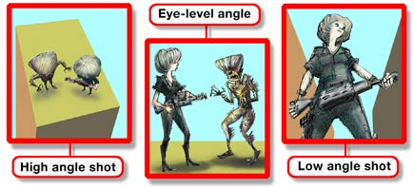

Other useful terms for shots are:

Point-of-view shot - helps us to see the action from a character’s viewpoint and thus empathise with them.
Two shot - Any shot with two people in it
Reaction shot - A shot showing a character’s expression as they react to something
Noddy - A type of reaction shot used in interviews, where we see the interviewer apparently reacting to the interviewee
Over-the-shoulder shot - A shot in which we see a character over another’s shoulder, often used in interviews or dialogues

Camera movement
In the same way that framing can be used to enhance our involvement in the film action, the way in which a camera is moved can be used to direct our attention to emphasise a particular viewpoint. Camera movements include:
Panning shot - where the camera pivots across from side to side from a fixed axis, to scan a scene or to follow a moving subject (A sudden, fast pan is known as a whip pan).
Tilt shot - where the camera pivots up and down from a fixed axis
Crane shot - where the camera, mounted on a crane, moves around at a distance above ground level.
Tracking shot - where the camera follows the action, moving along tracks laid for that purpose, often pulling backwards from a scene.
Hand held – this technique is often used to suggest a greater sense of immediacy or authenticity, for example it could be used to be used to provide ‘eye witness’ accounts of situations, linked to the point of view of a particular character or characters.
Zoom (lens) - These can vary the angle of view so that the subject appears to move closer (or further away) without the camera itself moving.

Mis-en-scene
French term from the theatre which literally means 'what's put in the scene'. This term is used in film to describe the elements of a shot. There are several areas to consider when talking about mis-en-scene:
- Setting and props
- Costume and make-up
- Body language and facial expression
- Lighting and colour
Each of these factors combines to give the shot a certain 'look' or 'feel'. What is put in or left out of a shot can make a big difference to the signals we receive about what sort of film it is and how we are supposed to feel at this point. Mis-en-scene establishes mood and atmosphere, and can express the inner life of characters through the way in which their settings are depicted on screen. For instance, a simple shot of a tree can be made to look threatening by adding a vulture and a storm and shooting it in darkness. The same tree can be given a very different look by having children playing beneath its sunlit branches.

Lighting & Colour
Lighting quickly creates an atmosphere on screen, it can be high or low contrast, and can vary in colour and direction. If it is dark and shadowy we might be made to feel uneasy, as in a thriller; if the lighting is bright we feel happy and confident. The filmmaker can use lighting to draw our attention to a person/object or equally, to hide them.
High-key - The lighting is bright and relatively low in contrast often used for Hollywood musical comedies.
Low-key - Much more pronounced shadows and dramatic contrasts.
Lighting from below - This can be used to make a subject appear threatening or horrific.
Backlighting - Produces a ‘halo’ effect around the edges of the subject.

Colour - Cold or blueish lighting can convey a sense of cold, alienation or technology, while warm or yellowish lighting can be used to convey comfort, sunset and so on. If colours are very rich and intense they are described as saturated.
Black-and-white or sepia can be used to show that a scene is set in the past, or to suggest sophistication.

Sound
There are three elements to a film soundtrack:
- Dialogue - this can be used to give us clues as to character and what might happen next.
- Music (The score) - this creates atmosphere, affecting us on a very emotional level.
- Sound effects (SFX) - again, very effective at creating atmosphere. These sometimes do not fit with the image that we are seeing, thus creating a disorientating effect.
Diegetic sound - Sound that we think is part of what’s going on on the screen horse’s hooves, the sound of thunder, and so on even though many of these will have been added later by a ‘Foley artist’.
Non-diegetic sound - Sound that we know is not part of what’s on screen, such as music (unless there's an orchestra in shot!) and voiceover.
Sound bridge - This uses sound to link two scenes, by having the picture and the diegetic sound change at different points. Usually the sound from the second scene is heard before we start to see the picture from that scene.

Editing
The term editing refers to how the individual shots are put together within a piece of film. The speed with which this happens has important role in creating atmosphere. For instance, if there is a car chase on screen, the editing will be rapid, making us excited. A countryside picnic scene, on the other hand, will probably feature slow editing, we relax and take in the details on the screen. Editing can vary both in pace (how long individual shots stay on the screen for) and in the transitions between shots.

Continuity editing - The majority of film sequences are edited so that time seems to flow, uninterrupted, from shot to shot. Within a ‘continuity editing’ sequence, only cuts will be used. Continuity editing can also involve ‘cross-cutting’, where a sequence cuts between two different settings where action is taking place at the same time.

Montage - In montage, different images are assembled to build up an impression. This is often used in title sequences.

Transitions describe the way in which one shot replaces the previous one:

Cut - One image is suddenly replaced by another, without a visible transition.
Cross-dissolve - One image dissolves into another. This can be used to make a montage sequence - eg the title sequence - flow smoothly; it can also be used in continuity editing to show that we have moved forwards in time and/or space.
Fade up - An image gradually fades in
Fade out - An image gradually fades out. Fades to and from black usually mean that time has passed. This is usually, though not exclusively, used as a kind of visual 'full stop', signifying that the scene in question has finished.
Wipe - One image replaces another without dissolving, with the border between the images moving across or around the screen.

Title graphics
The way in which the title and credits of a film are written and the colours chosen for both them and the background tell us what type (genre) of film to expect. A horror film might employ a red Gothic font, whereas a science fiction film may use a bright green colour on a black background.
Some other film terms A-Z

Biopic
Short for 'biographical picture', a film (or, less frequently, a television programme) devoted to the life of a real historical or contemporary figure. Although it might be counterintuitive, the biopic is essentially a fictional portrait, typically with a great deal of creative licence. Characteristic is the biopic of a long-dead figure about whose life relatively little may be widely known; British kings and queens, for example, have been popular subjects, even in Hollywood films. Regardless, biopics vary greatly in the extent to which historical accuracy is even an objective, and the form is often only tenuously related to the research-based literary biography. What is defining, however, is the extent to which the film takes as its subject the life of the individual in question, even if in doing so it depends much on conjecture, imaginative evocation or even deliberate myth-making. Thus, The Private Life of Henry VIII (1933) would not satisfy most historians but certainly qualifies as a biopic; Shakespeare in Love (US, 1998), in which the life of the playwright is part of a wider evocation of the Elizabethan court, might still qualify; A Knight's Tale (US, 2001), in which the character of Geoffrey Chaucer appears in a supporting role in an otherwise wholly fictional 14th Century England, would not.

Cinematographer
The person whose job it is to set up both camera and lighting for each shot in a moving image text. The cinematographer has perhaps paramount influence over the look or tone of a shot or scene, and is often held in as high esteem as the director. Cinematography is therefore the art of positioning a camera and lighting a scene.

Director
The person responsible for the physical creation of a film or television programme, who is often the final decision-maker with regard to creative matters.

Distributor
The middle section of the chain of production-distribution-exhibition in the film industry. The distributor buys, then re-sells or rents a film property. They are crucially responsible for marketing individual films or videos.
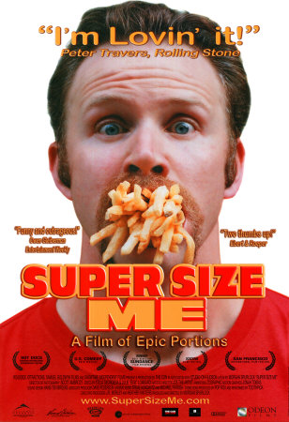
Documentary
Not so much a single genre as an umbrella of related programme types, each seeking to represent versions of reality. Documentary forms have evolved from the beginnings of cinema to contemporary so-called docu-soaps, which some people might not see as being 'documentary' at all. They are characterised by relatively 'high modality'.

Editing
The process by which shots are put together into sequences or scenes. Usually described according to rhythm or pace (i.e. the varying lengths of the shots in the sequence) and type of transition (e.g. cut, fade, dissolve or mix, wipe). A montage sequence is a series of shots which summarise an action or build a mood, rather than playing it out in the equivalent of real time.

Genre
A way of categorising different types of moving image texts. As it has a particular usage in Film Studies it can often sound clumsy or inappropriate when applied to other media forms, like video or television. It is more common to talk of television formats, like the gameshow or the chatshow, for example. Genres are typically studied via reference to narratives, iconography, themes, and characters which crop up relatively predictably within individual examples of a particular genre. However, it is important to bear in mind the role of the audience when studying genre. It is commonly agreed that audiences enjoy both the repetition of what is familiar in any example of a genre, but also expect to see something new.

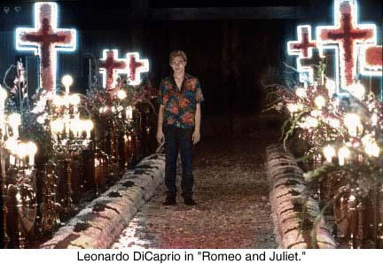
Iconography
Refers to single visual elements of a shot which resonate beyond their literal meaning or representation. Thus a particular kind of motor cycle in films like Easy Rider (US, 1969) has come to signify a whole counter-cultural movement. Iconography refers to a whole system of icons with the same range of reference - what in English would be called a 'semantic field'. Thus Baz Luhrmann's Romeo and Juliet (US/Canada, 1996) features iconography - boots, guns, cars, clothes - associated with specific groups of young men in contemporary Los Angeles.

Melodrama
A form of drama relying on an unrealistic, exaggerated style, often involving heightened emotion. Melodrama is often despised by critics for its deliberate avoidance of realism, but it can be immensely popular - Titanic (1997), for instance, is pure melodrama, and the so-called Gainsborough melodramas were amongst British cinema's biggest box-office successes in the 1940s.

Producer
The person ultimately responsible for the creation of a film or programme. Usually involved right from the start, the producer will either devise or purchase the original idea, calculate the likely budget, pitch the idea to financiers to raise the money, hire the necessary creative personnel, supervise all stages of production and marketing, negotiate deals with prospective distributors or broadcasters and be the first point of contact for anyone interested in the production in question. Although often disparaged as being purely a business role, the best producers have considerable creative input as well, and highly regarded producers such as Alexander Korda and David Puttnam have a body of work as distinctive and artistically consistent as that of any of the directors they worked with.

Shot
The basic unit of meaning in a moving image text. It can be described according to its length, or duration, the way it is framed (i.e. the camera distance and angle), and the arrangement of elements within it (often referred to as the mis-en-scène).

Spoof
A film or television programme that pokes fun at specific films, genres or people for comic or satirical effect.

Stereotypes
Often used as a derogatory term for a quickly drawn or 'stock' character, and criticised as lazy or deliberate misrepresentations of people or groups. Actually stereotypes have a specific function and force in any text, which it is often useful to explore in a reasonably unprejudicial way.

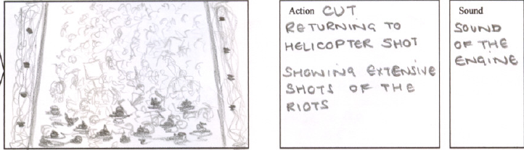
Storyboard
A series of drawings illustrating the way that a director plans to visualise film sequences, showing how each shot will appear. They range in quality from rapidly scribbled sketches (sometimes by the director himself) to, in the case of big-budget films with large production teams, elaborate artworks produced by professional artists. Although some directors choose not to use them, storyboards can be a valuable accompaniment to the screenplay, especially if the film is visually ambitious.

Surrealism
Although the term 'surreal' has (too) often been used merely as a synonym for 'weird', Surrealism is a fully-fledged philosophical movement created by French intellectuals in Paris in the 1920s, whose central feature was the exploration and championing of the workings of the unconscious mind. Key Surrealist artists include the writers André Breton and Paul Eluard, the painters Salvador Dalí, René Magritte and Max Ernst and the filmmaker Luis Buñuel. Although Britain did not produce any high-profile Surrealist filmmakers as such, Humphrey Jennings and Lindsay Anderson have been cited, and it is not uncommon for films to show surrealist touches.

Sources
http://www.screenonline.org.uk/education/glossary.html
http://www.mediaed.org.uk
Yardley, N. Scriptwriting and Film Techniques (2002), Five Senses Education Pty Ltd, Seven Hills.

Practice: What camera and film techniques can you identify for the following shots, and what are the effects of these element?
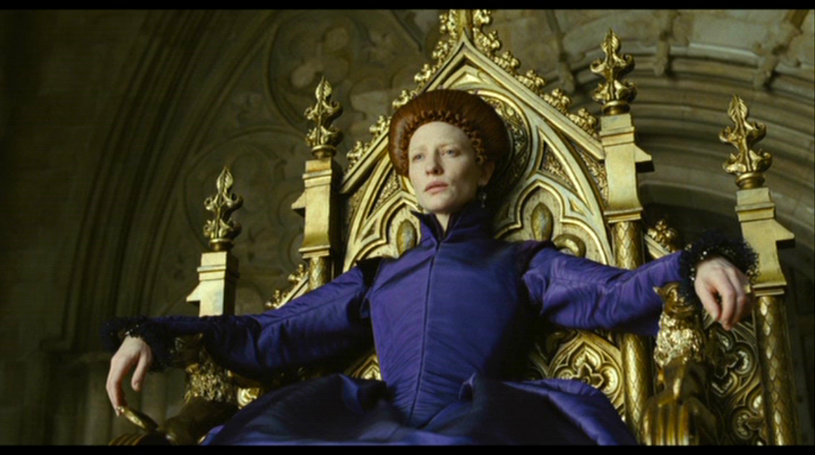

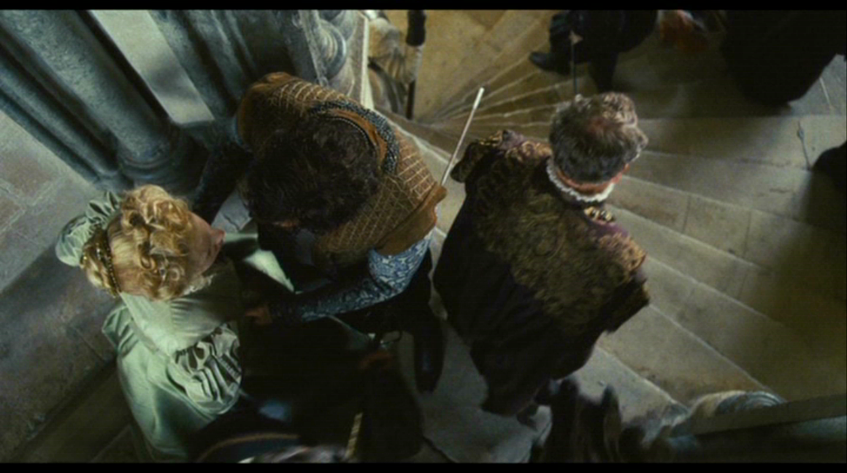

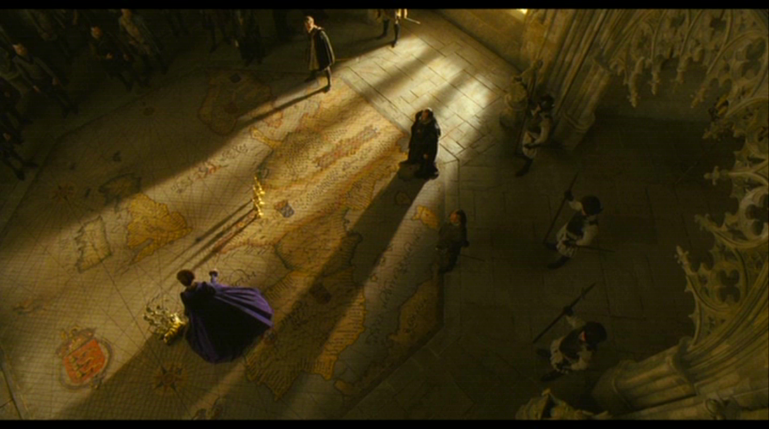

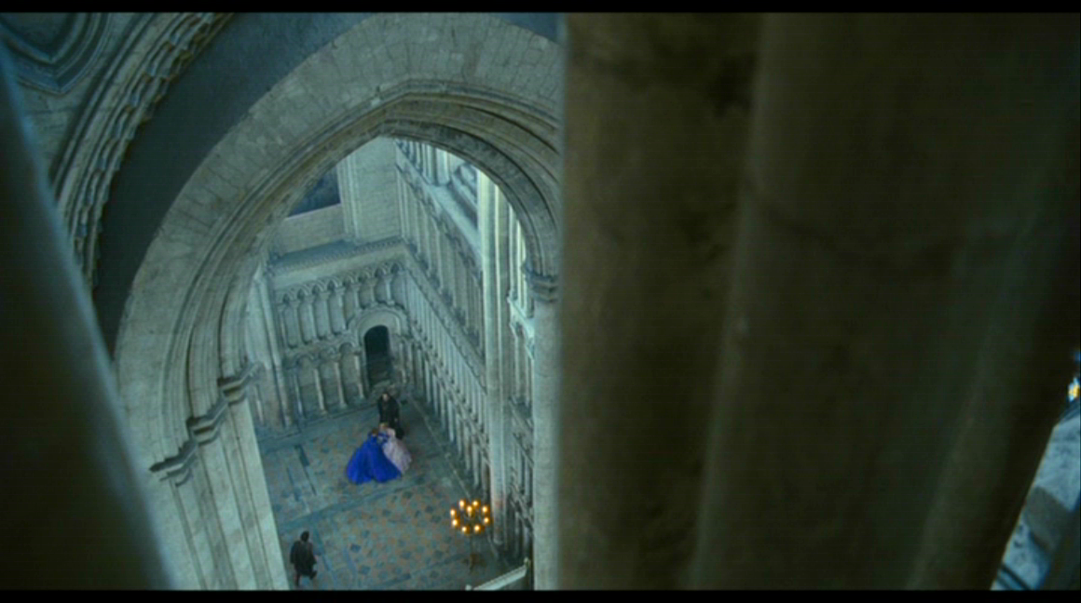

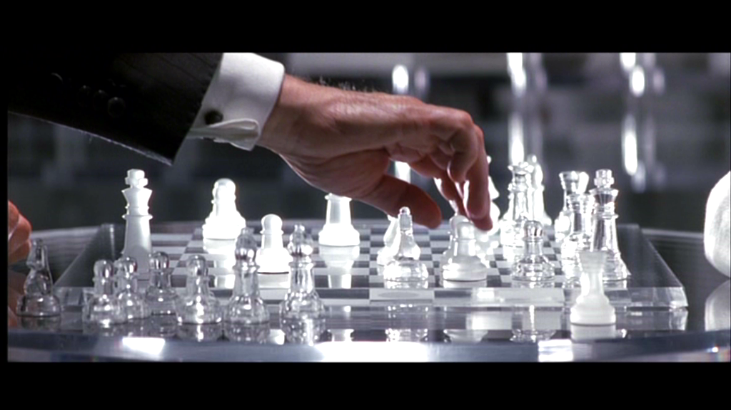

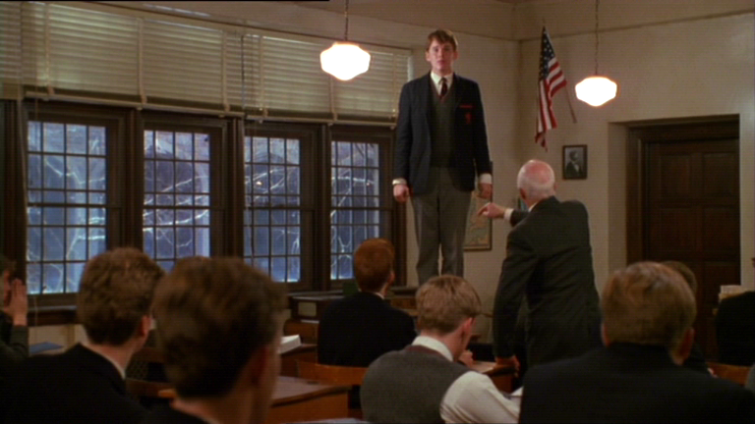

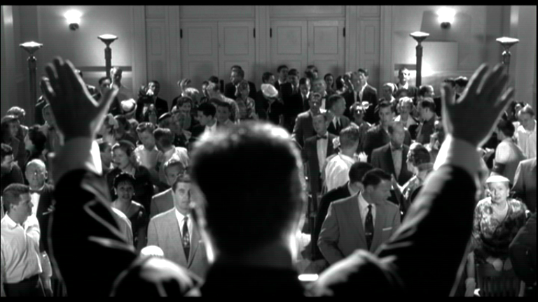

Shots from:
Elizabeth: The Golden Age, Universal Pictures 2007
X-Men, Twentieth Century Fox, 2000
Dead Poets Society, Touchstone Pictures, 1989
Pleasantville, New Line Cinemas, 1998

