Schindler's List – Film Questions
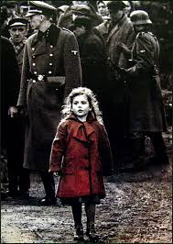
1. There have been many atrocities committed throughout history. The Holocaust was not the first or the last. Why is the Holocaust recalled with such horror?
2. Why didn't the Allied Powers, who knew that mass killings were taking place, focus their firepower on the human ovens and the Nazi killing operations?
3. In this film almost none of the Jewish characters that we get to know well are killed. Why is that?
4. Why is this film shot mostly in black and white? What were the advantages to filming these events in black and white? Colour is used only four times in the film. Why are certain scenes shot in colour?
5. Can you describe the personal relationship that developed between Itzhak Stern and Schindler?
6. Schindler's wife, Emilie, who was very much his partner in his heroic efforts, said, "We only did what we had to do". How do you connect this statement with the actions of most of the German people who lived during the Second World War and who permitted the Holocaust to occur without protest?
7. Schindler was a gambler and an opportunist who liked living on the edge and outsmarting the Nazis. Does the fact that he may have had a talent for emotional manipulation and for cheating the authorities take away any of the glory of his accomplishments? A similar comment can be made about Emilie Schindler- that she was to a certain extent only following the lead of her corrupt husband and being a 'good wife.' Does this take away any of the glory of her accomplishments?

